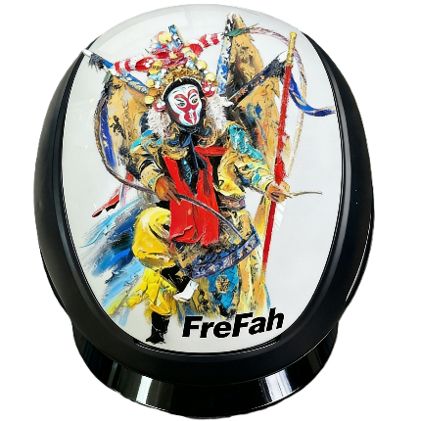
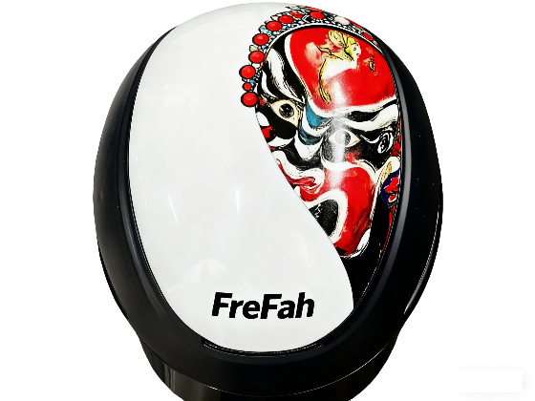

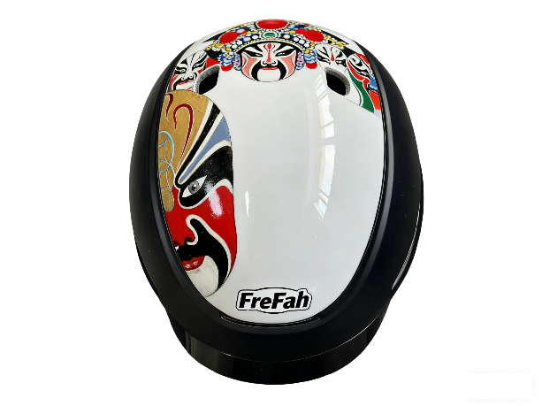

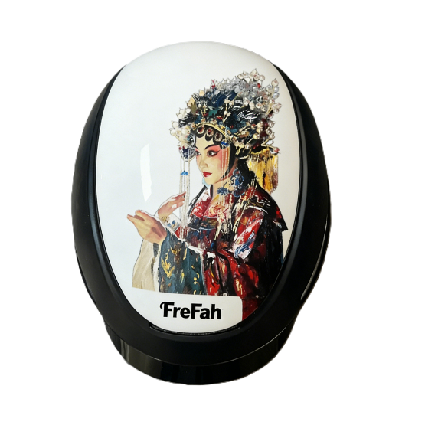
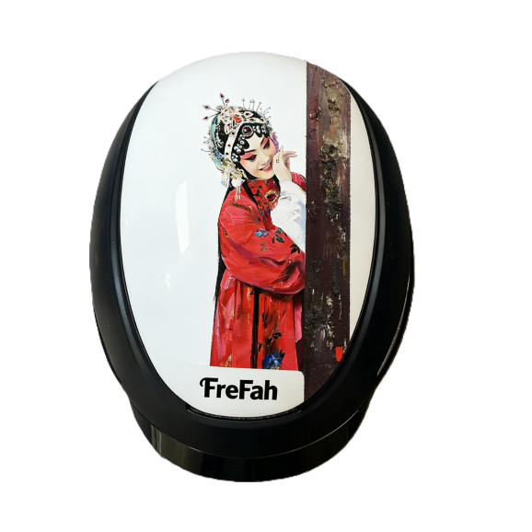

The introduction of Painter
Liu Sen zhen, gratuated from Central Academy of Fine Arts, and his outdoor sketch work <The RongCheng Scenery> and < The Grandness of Sea Rhyme> was praised and collected by the academy itself. He started his independent art creation since 2006, choosing the Beijing Opera as his creative image, is not so much his creative choice as the natural combination of his passion for Chinese national culture and art with his painting genius.
His works is characteristic of the unique technique of color using, and he fleshes out the characters of the Beijing Opera. His unique and praiseworthy technique presents us the exaggerative theatrical expressions of characters and consummate acrobatics;
His works is favored by many domestic and foreign collectors, and most importantly, his works such as ‹Chinese Four Beauties> and ‹The character series of the Bei Jing Opera> respectively were collected by Mr. Nick and Ms Jennie from America, ‹The Lady General Yang> was collected by Mr. Derry From France.
.

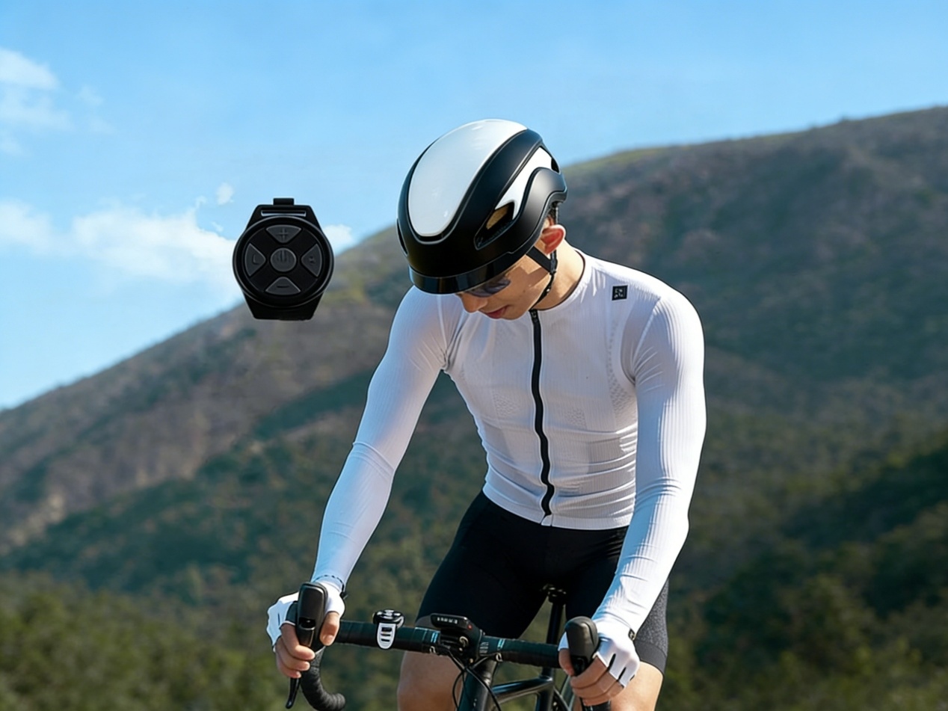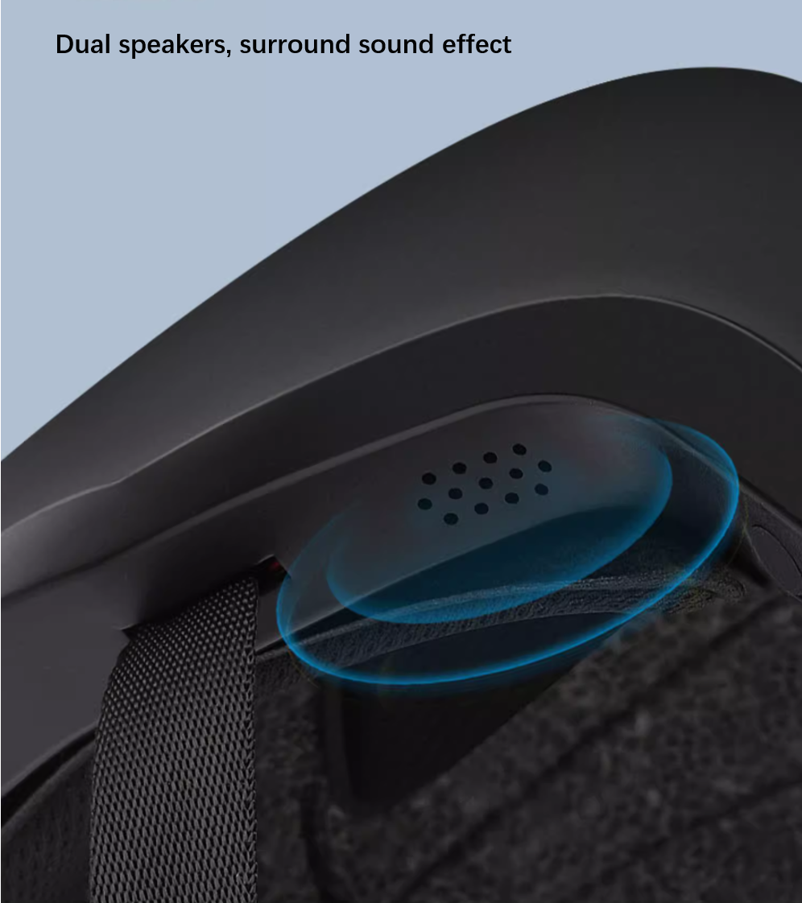
One-touch control for calling and music
The remote Controller fixed onto the bicycle handlebar

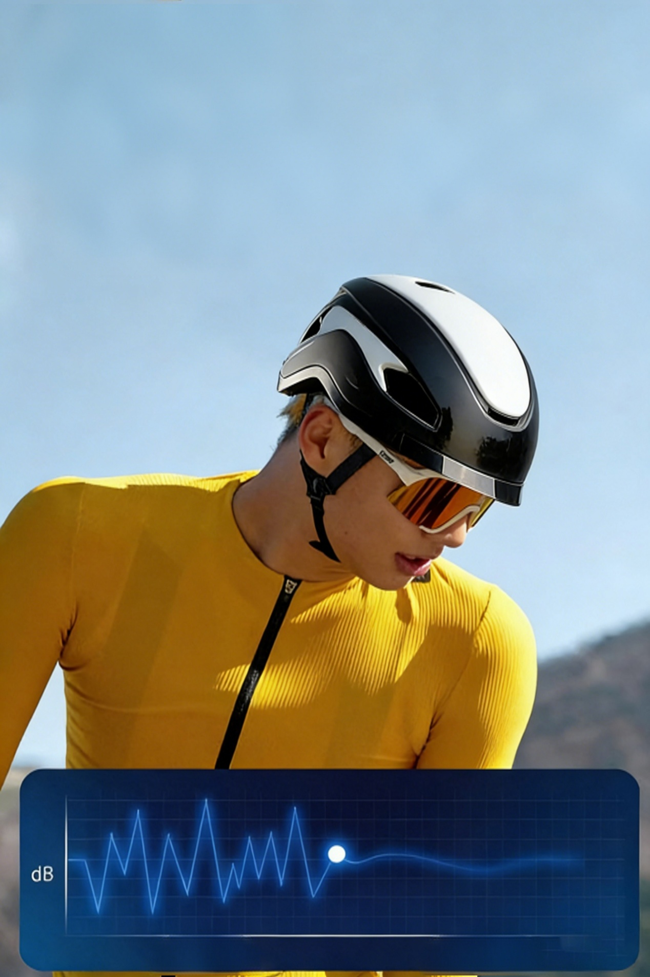
Noise-Cancelling Technology
Clearer Navigation
Comfortable wearing
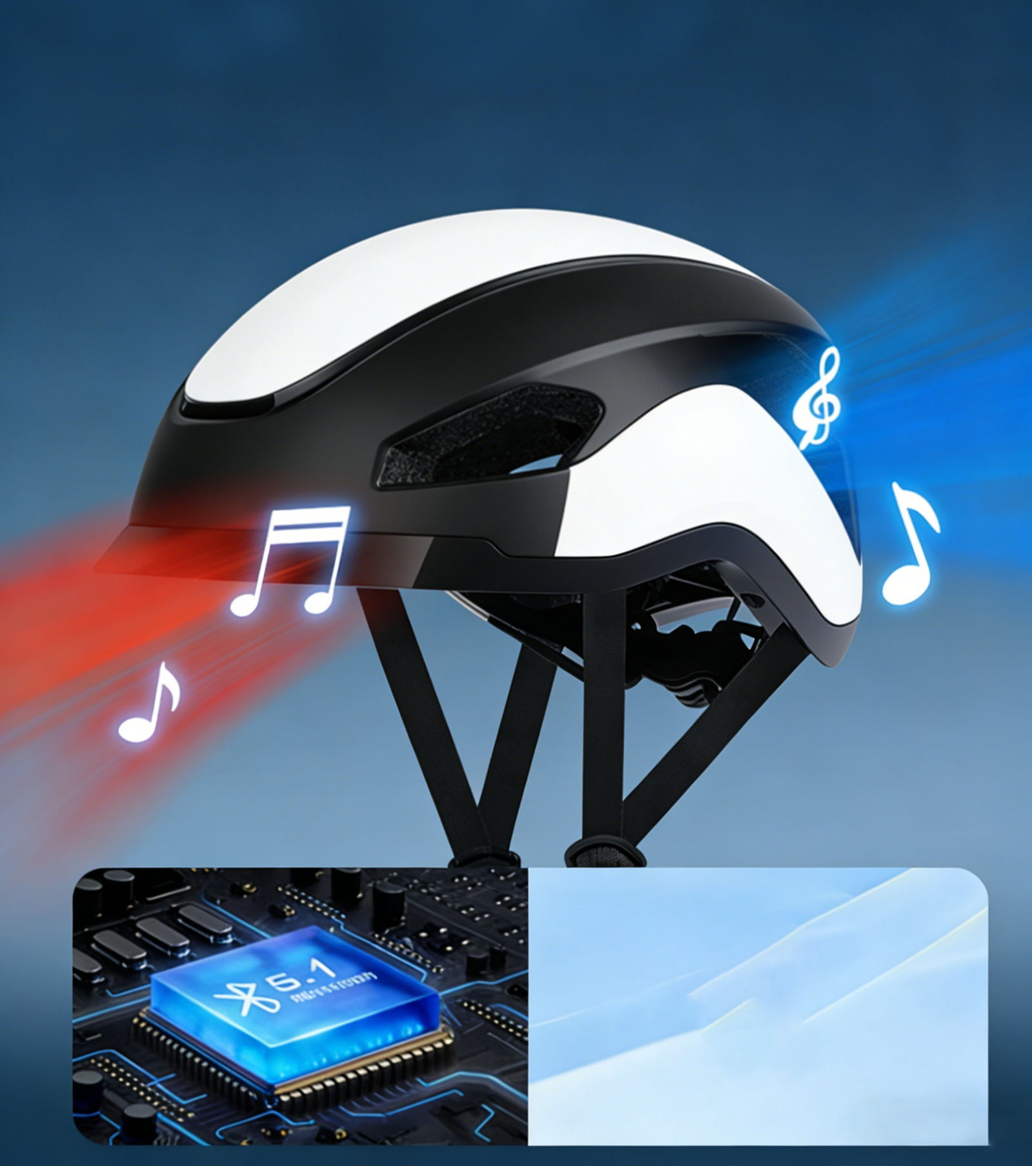
Bluetooth 5.1

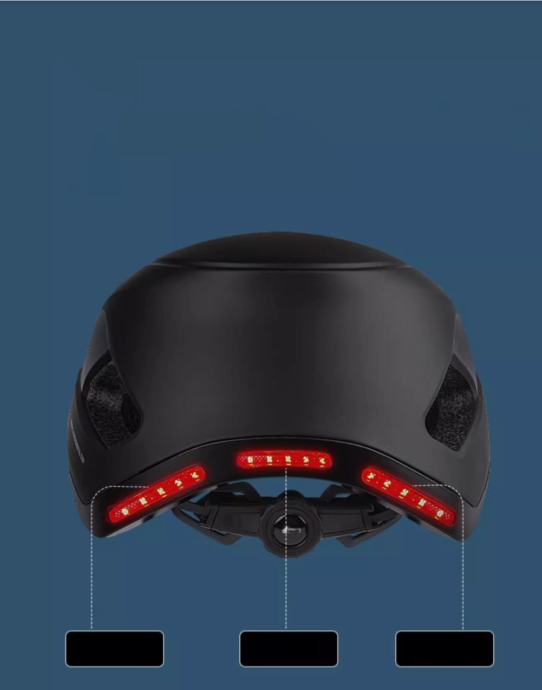
L turning light Warning light R turning light

3 built-in LED lights
Controlled by smart remote controller
Safer riding at night
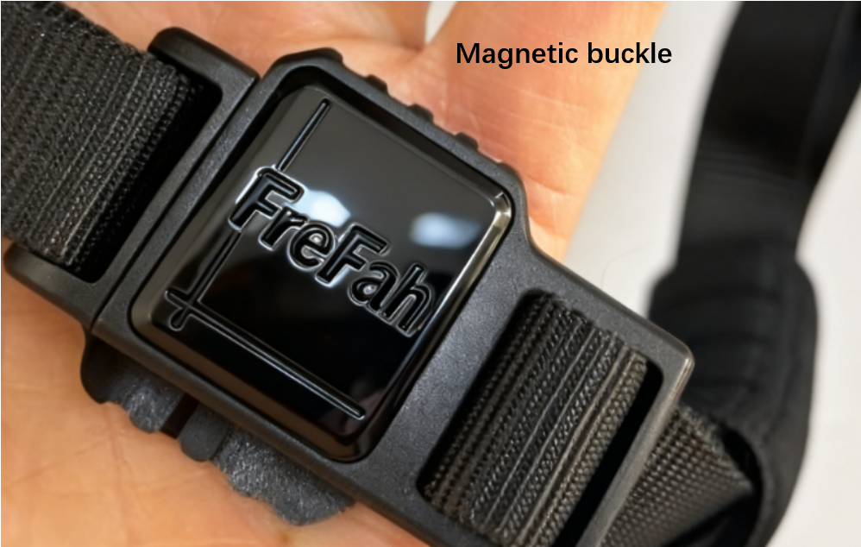
Magnetic buckle
Antibacterial and deodorant
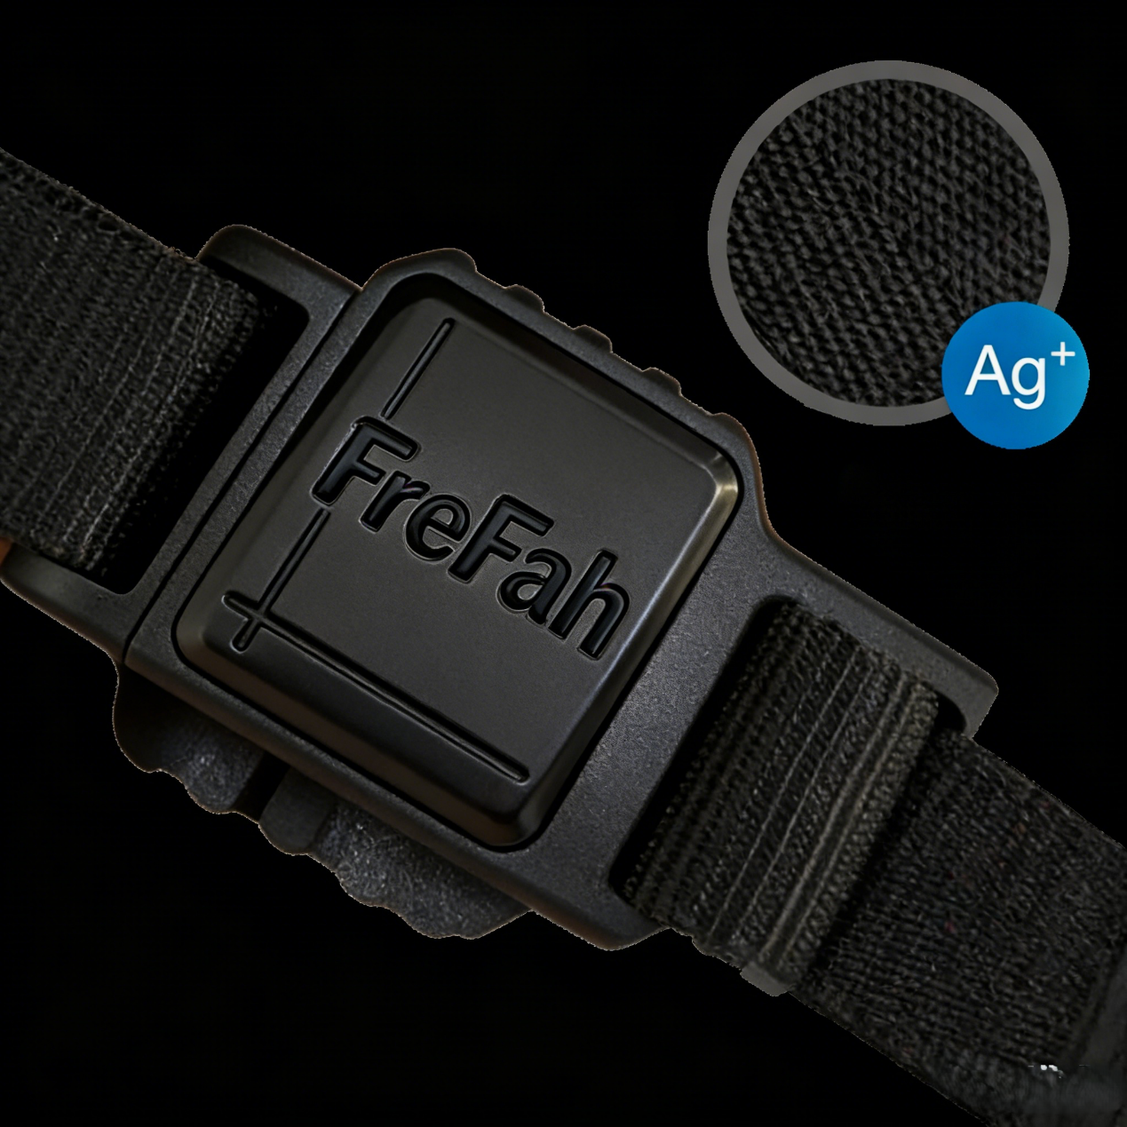
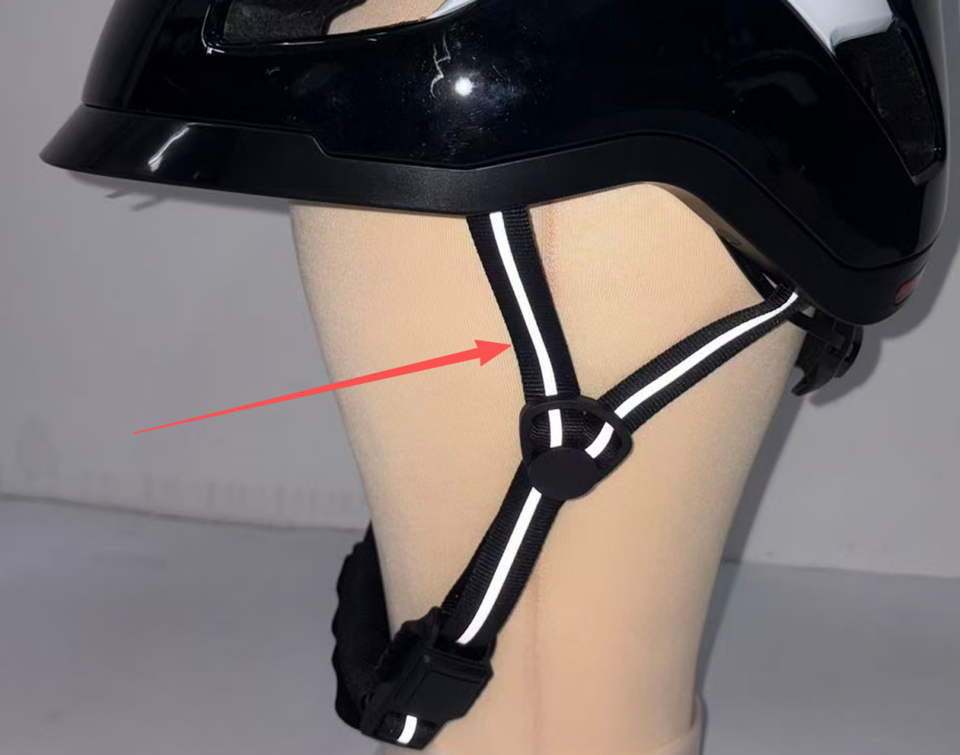
Reflective strap system

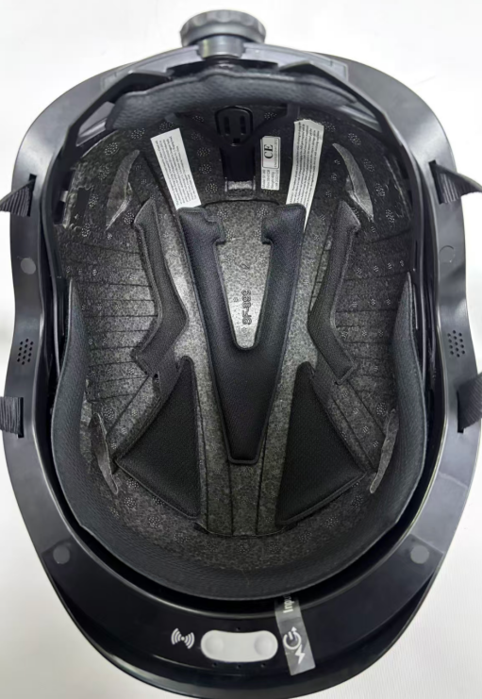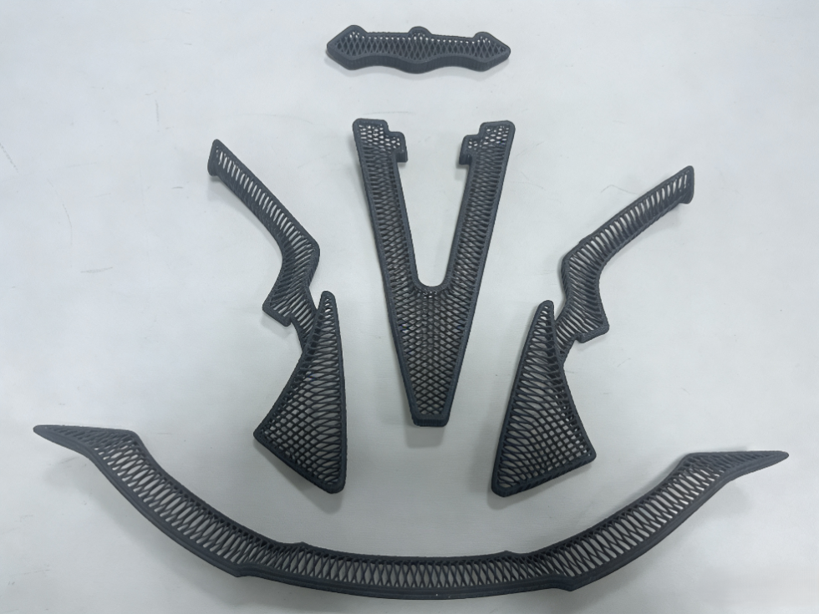
3D-printed Lining=common fabric lining+Mips Function
5M function:
- More safer for cushioning impact,
- More ventilated and breathable,
- More comfortable,
- More anti-sweat,
- Much easier for cleaning

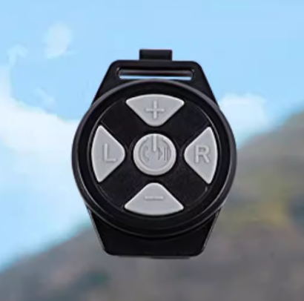
Button Functions:
A – Power on/off:
B – Turn on/off the left turn light
C – Turn on/off the right turn light
D – Volume increase button/Long press the previous song
E – Volume Reduction Button/Long press the next song

